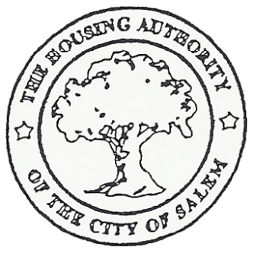
HOUSING AUTHORITY OF THE CITY OF SALEM

205 Seventh Street, Salem, NJ 08079
Telephone: (856) 935-5022 Fax: (856) 935-5290
Web Site: salemhousingauthority.org
A CLOSED SESSION MEETING
THE HOUSING AUTHORITY
OF
THE CITY OF SALEM

July 18, 2024

Resolution No. 36 of 2024 Resolution Authorizing Closed Session

Roll Call Vote:
Motion: Commissioner Joyce Lewis
Second: Commissioner Dawn Johnson

Roll Call: Unanimous
 | Motion | Second | Yea | Nay | Abstain | Absent
Chairwoman Mortiz |  |  | X
Commissioner Nichols |  |  | X
Commissioner Henson |  |  | X
Commissioner Johnson |  | X | X
Commissioner Lewis | X |  | X
Commissioner Wood |  |  | X
There was discussion regarding a lawsuit received from the New Jersey Foundation for Open Government v. Salem Housing Authority.

Solicitor Telsey explained that we have been served with an Open Public Record Act complaint. There are two complaints (1) The Salem Housing Authority did not timely respond to an OPRA request from June 6, 2024. The request was for minutes of meetings and resolutions; and (2) the authority did not follow the statue by posting minutes, resolutions, the budget, audit and agenda information on the website.

Solicitor Telsey recommended that Director Upshaw provide the requested documents stated on the OPRA request and to update the website to be in accordance with the statue. Solicitor Telsey also added the authority will be obligated to pay the plaintiff attorney’s fees.

A motion was made by Commissioner Dawn Johnson to go out of Executive Session and seconded by Commissioner Joyce Lewis. The motion was unanimously approved by all present.

